Q370: Experiments and Models in Cognitive Science
Apparent Motion Laboratory

When assessing your own subjective experience of apparent motion, not only are the correspondences between elements across frames relevant, but the strength/goodness of motion and its resistance to change should also be considered. In answering the following questions, try exposing yourself (and friends) to the same display a number of times and base your answers on the most frequent interpretation given.

1. By arranging two objects in two frames like
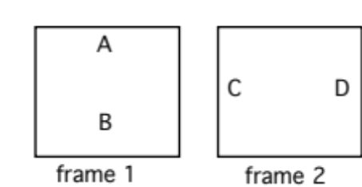
one can see whether A corresponds to C (and B to D) or whether A corresponds to D (and B to C). Using this procedure, you can explore which of two features is more influential in determining apparent motion.
- Draw two frames that allow you to test whether color or shape is more important for determining motion. Why did you choose the colors and shapes that you did? Describe (draw and label) your displays. Describe your results. Given your results, which dimension is more important?
  - When designing this experiment, I selected a blue circle for A and a red star for B. Then for the second frame, I defined C as a blue star and D as a red circle. This allowed me to address all variables and allowed me to perceive whether color or shape is more important in determining motion.
  - Personally, I saw my two objects rotating 90 degrees counterclockwise and then rotating 90 degrees clockwise oscillating between the two different shapes but remaining the same color. This points to color being the more important dimension in my perception between color and shape.
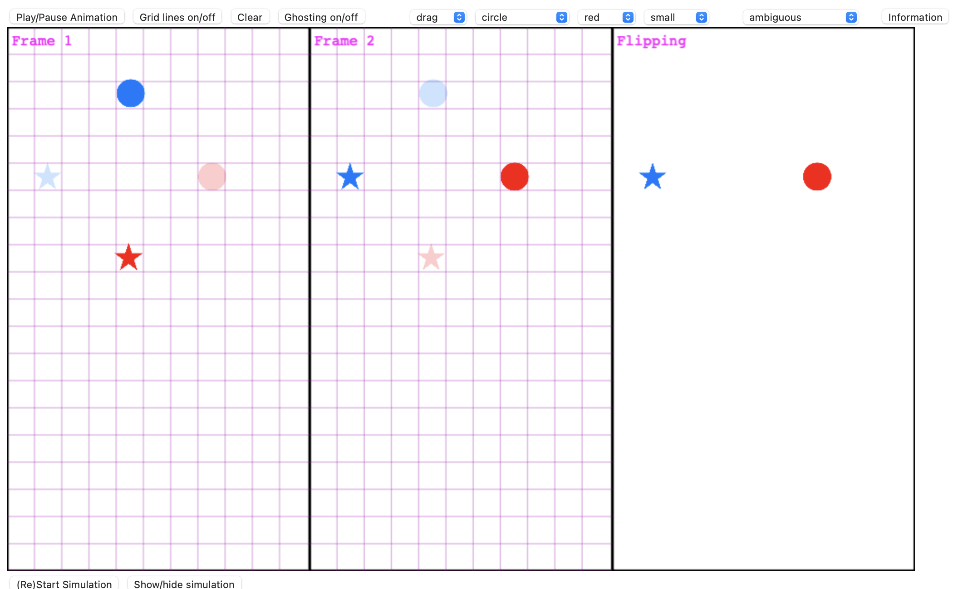
- Do the same, pitting color against size.
  - For this experiment, A was a small blue circle, B was a large red circle, C was a large blue circle, and D was a small red circle. Within this experiment, I saw the objects rotating 90 degrees clockwise and then 90 degrees counterclockwise. Maintaining their size but changing their color with my perception points to size being the more important dimension between color and size.
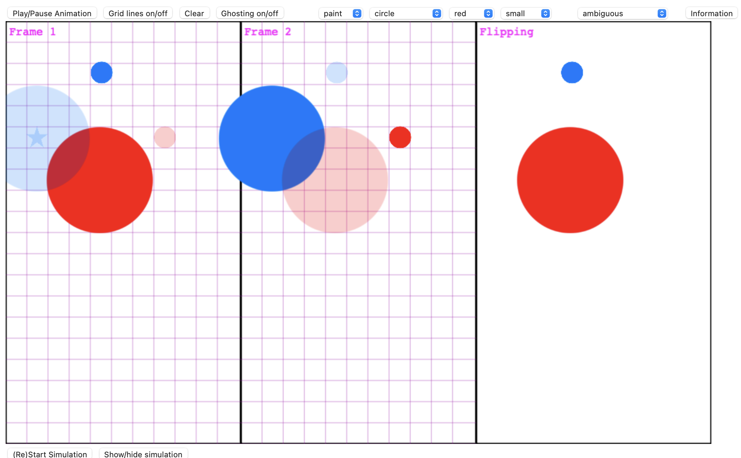
- Do the same, pitting size against shape.
  - For this experiment, A was a small blue circle, B was a medium blue star, C was a small blue star, and D was a medium blue circle. Within this experiment I saw the objects rotating 90 degrees counterclockwise and then rotate 90 degrees clockwise. Maintaining their size but changing shape points to size being the more important dimension between size and shape.
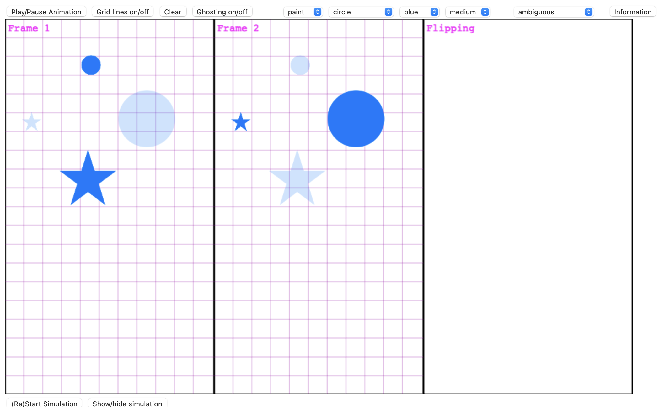
- There is neurophysiological evidence for two separate visual pathways. The Magnocellular pathway is particularly sensitive to motion, coarse outline, and timing. The parvocellular pathway is particularly sensitive to color (hue), detailed form, and spatial relations. Do your results from A support this distinction? Why or why not?
  - My perception does support the visual pathway distinction between parvocellular and magnocellular pathways. By synthesizing the parvocellular and magnocellular information, I was able to perceive the colors moving instead of the defined shapes. If I instead saw the shapes moving, my visual perception would be unaligned with this dual model understanding of the visual system.
2. According to the one-to-one mapping constraint, we have a bias to see every object in one frame correspond to one and only one object in the second frame.
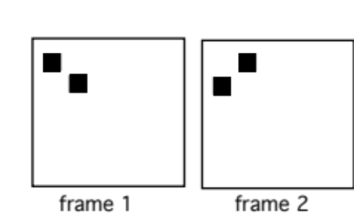
- How does your perception of these frames support the one-to-one mapping constraint?
  - When moving between these two frames, I see horizontal motion of both elements. There is no intermediary perception of one element splitting or deleting. Essentially for every element, I perceive one element in the next frame that corresponds to that previous element.

However, a consideration of the frames
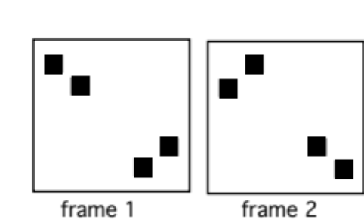
leads one to suspect that there may be more going on than simply a one-to-one mapping constraint in A.

- Describe what you (and your friends) see in the second situation, and why this suggests a possible alternative account (other than simply a preference for one-to-one-mappings) for the first situation in Question A. That is, why might people see the motions that they do in Question A even if their perceptual systems did not have a one-to-one mapping constraint? Be as specific about this alternative as possible
  - An alternative is the importance of proximity between elements rather than solely relying on the one-to-one relation between elements. Relying on just one-to-one mappings may result in apparent motion between the two clusters but, upon viewing the animation, elements that within their cluster.
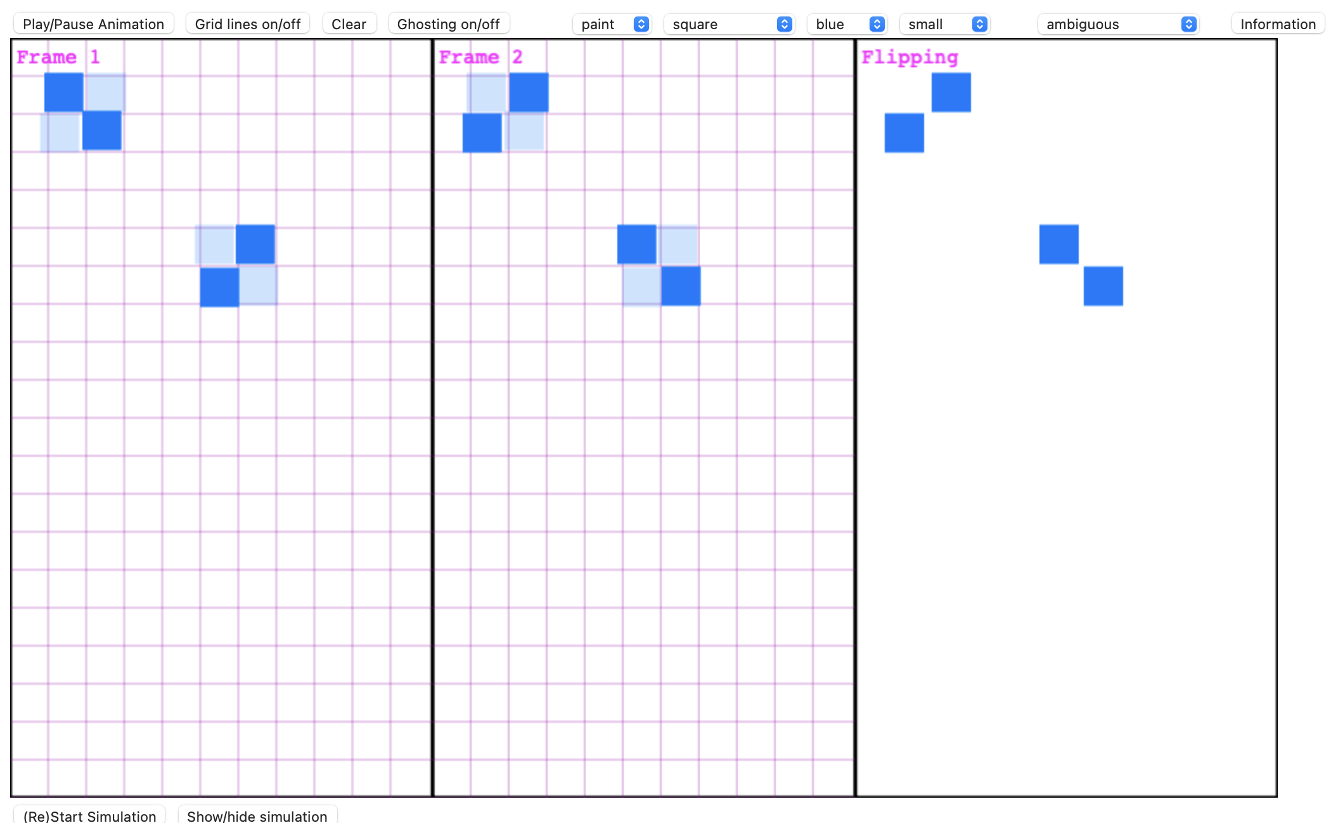

- Design a display that tests whether there is still a one-to-one mapping constraint without the possible confound described in B, and show a drawing of your frames. Do you still find evidence for a one-to-one mapping constraint? If so, what is your uncontaminated evidence?
  - Within this experiment, if we were to assume that a one-to-one mapping existed, the top left circle would move down into the bottom right corner. But, the perceived apparent motion has the top circle disappearing with the bottom circle splitting into two. This shows that a one-to-one mapping is not the sole confound within apparent motion experiments.
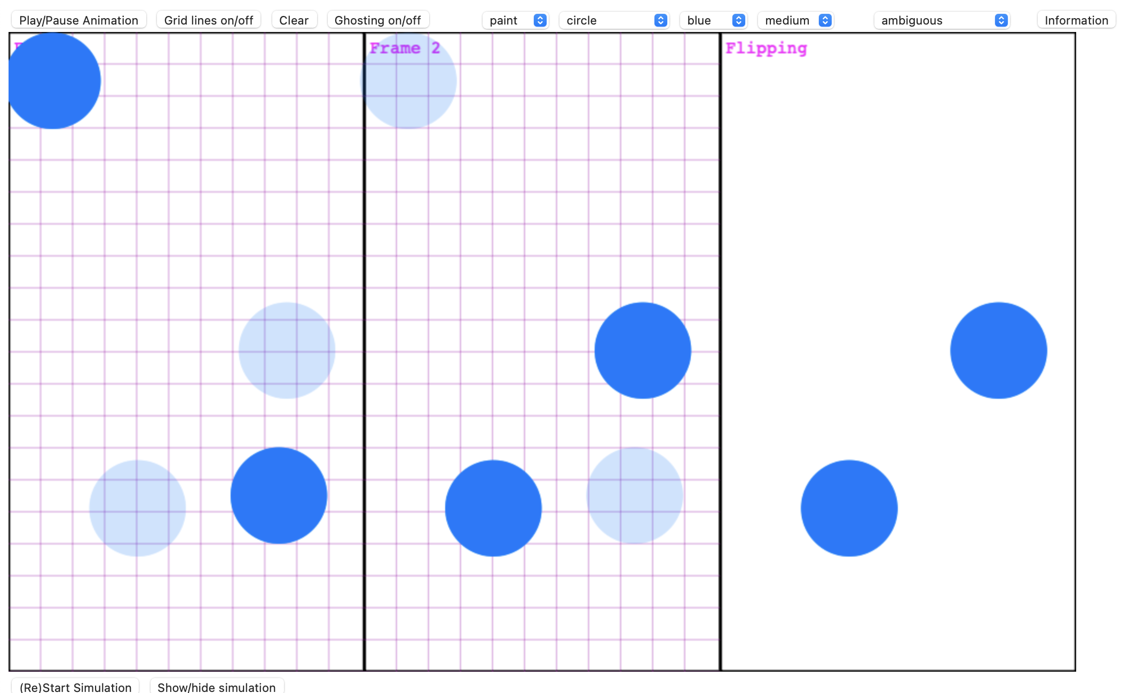

- Consider the Ternus effect:
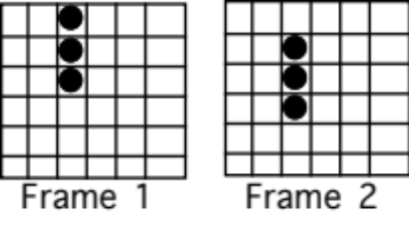

There are two major interpretation that people give for this display, and you can see them both by changing "Blank Time" from 0 to a somewhat larger number of milliseconds. Describe the two interpretations that you see by describing which dots correspond to each other for each interpretation. Explain why "Blank Time" has the influence that it does.
Interpretation 1:
The first interpretation that I see with a longer blank time is the translation of all three dots vertically. The apparent motion is motion of each dot moving up and down with their partners, together.
Interpretation 2:
The second interpretation that I see with a shorter blank time is the rotation of the top two dots 180 degrees into the bottom two dots in the next frame. This means that one of the dots stays static as the other two dots rotate around the anchor point.

Blank time has this effect because having a longer period where all three dots are removed allows for my perception to understand that all three dots have been removed from the scene. When blank time is shorter, this understanding that all three have been removed is not as clear to me as the viewer. Because of this, there is an assumption that possibly one or more dots have remained unchanged between the two scenes. This creates the Ternus (rotational) effect.
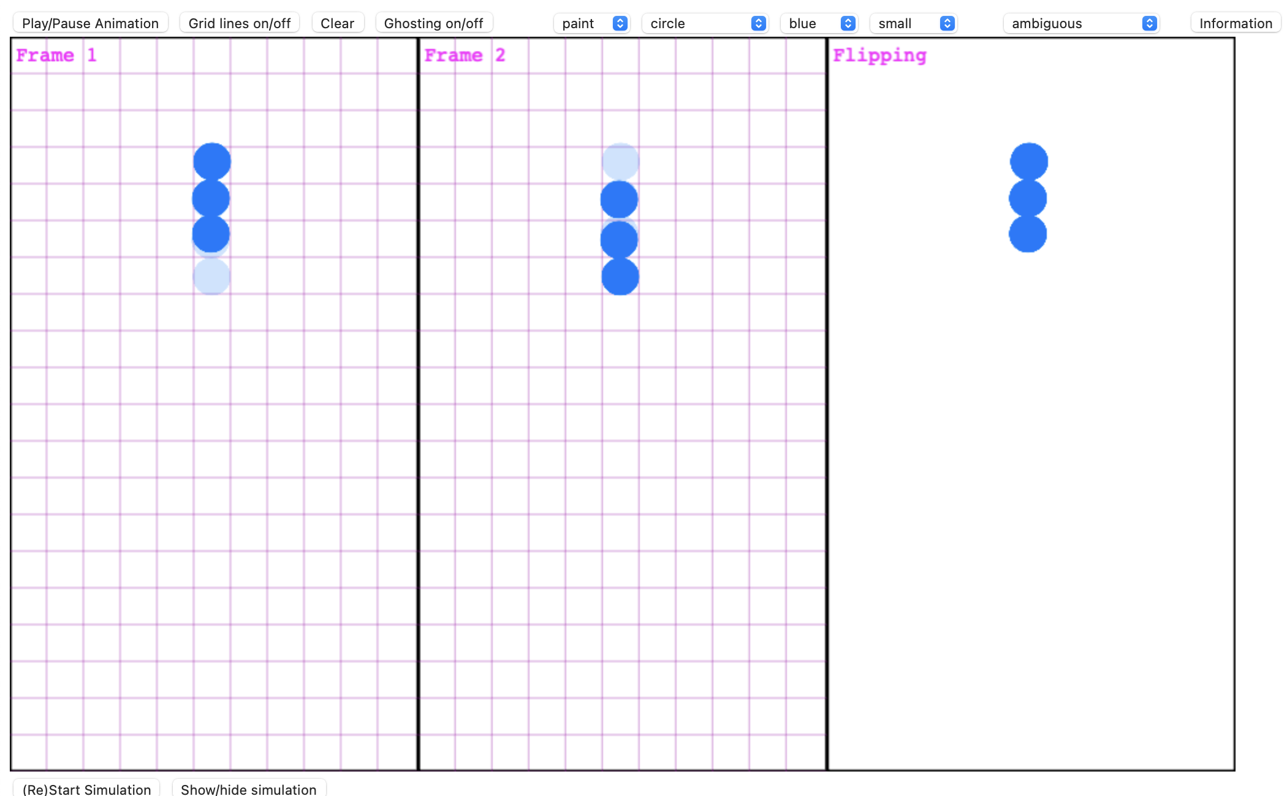
- The computational model can also produce either of these interpretations. Report two parameter settings that produce the same two interpretations that you found, and that only differ on one parameter value. Given this simulation outcome, what does the model say is one of the effects that increasing the blank interval between frames has? Does this make sense? Why or why not?
- Modifying solely the speed variable can create the desired two interpretations within the simulation. At a high speed, we see the simulation agreeing with complete vertical translation of each element. At a slower speed, the opposite understanding, the Ternus effect, becomes more and more probable. This does make sense as the blank time variable for the frames correlates to speed within the simulation as we are modifying the speed at which we as subjects are presented with the stimuli.
- Fully describe (include a drawing, model parameters, and timing information) a situation where the simulation makes the wrong prediction (given your own perception) when "Match" is set to 0, but makes the correct prediction if Match > 0. Ideally, setting Match > 0 should be the only way of successfully modeling the situation. What does this suggest about when and why the Match constraint is important? In particular, why is the one-to-one mapping constraint not sufficient?
Wrong
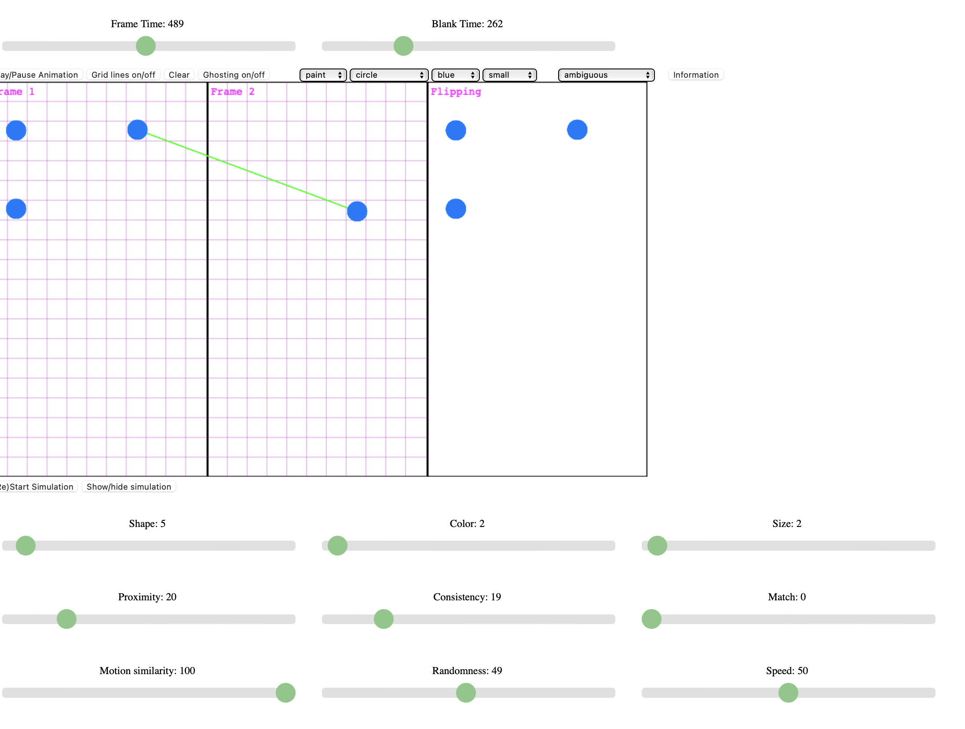
Right
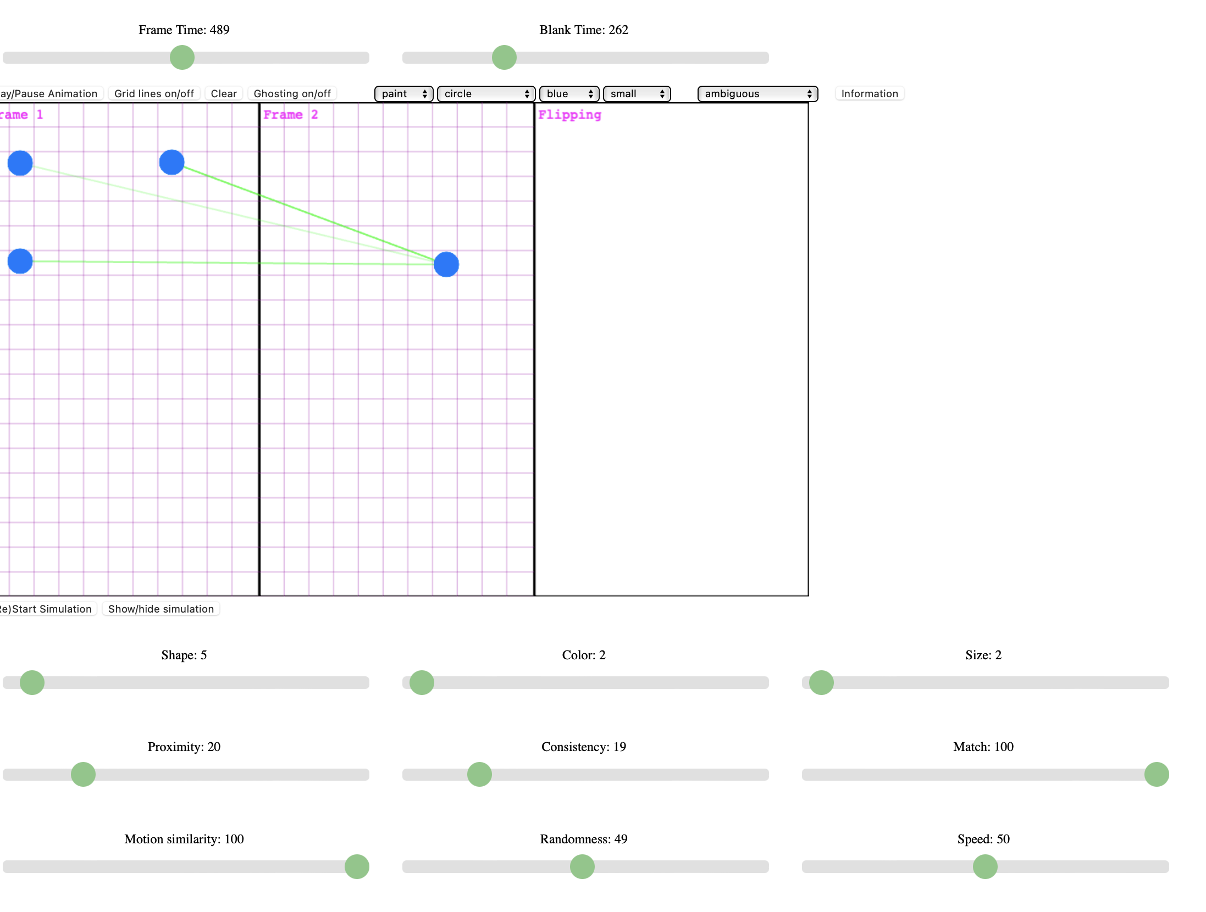
The match constraint illustrates similar motion between the objects and shows that 1:1 motion isn’t necessarily true. I personally see all three dots colliding into one. But, under the 1:1 mapping, this is impossible. Therefore, there are other weights and balances besides 1:1 that are forces behind our perception.

- Even though I programmed the model (adapted from models by Dawson and Ullman), I can see that it is far from perfect. Describe a situation where the computer model and the human perceiver do not agree. Describe the discrepancy between the human and computer. You should make reasonably sure that no parameter setting would allow the model to see what the human sees. One example of a genuine failure of the model is that people sometimes see rotation of objects in 3-D. If people are shown the two frames:

they will often report seeing an entire complex object rotate in depth. The model has no way of seeing such motions and was not intended as a model of 3-D motion, and so there's really no way that the model could possibly get the right answer. You can't use 3-D perception as an example now that I've mentioned it, but there are plenty of others. Finally, for your situation, describe as specifically as possible, how you would modify the model to show more human-like behavior.
- An example of where there is a fault in the model is the fact that humans can see motion that is at a higher frame rate and therefore we get more sensory data to correlate illusory motion over a greater period of time. With the limitation of 2 frames, the model is unable to perceive a greater difference over time that I believe is essential to human perception. To make this model better, I would create more possible frames to see if the illusory motion that the model hypothesizes correlates with the motion that humans perceive over MULTIPLE frames of motion.

